Exclusive Car Service

Where to Find Your Limo

**Contacts:**

Voice: 877-mylimo5

Email: [sales@Mylimo5.com](mailto:sales@Mylimo5.com)

Web: TBD

**Call 877-695-4665 24 hours prior to arrival to get drivers’ cell phone number.**

Bradley International Airport – Hartford/Springfield:

Bradley International Airport is the easiest destination for any traveler; easily accessible to both Connecticut and Western Massachusetts. This airport has two terminals, each with a luggage carrousel on the lower level. Unfortunately, our drivers will be unable to leave their vehicles, unless we are notified in advance, so arrangements can be made with airport security. After you collect your luggage, feel free to call your driver if their number has been provided or requested. If not, please proceed to the outside pick-up/drop-off location through the doors right next to the South-West Airlines. All drivers will be waiting outside baggage claim 1 near the curb. Please refer to the photograph below. If your driver has been given your phone number, they will call you fifteen minutes after you land.

**Terminal A: (Air Canada, American Airlines, American Eagle, Delta, Jet Blue, Southwest Airlines, United Airlines, US Airways, and US Airways Express).**

**Terminal B: Currently under construction.**

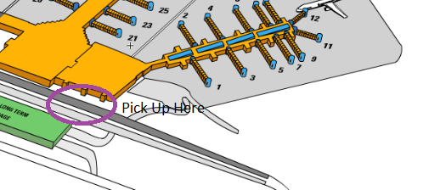

Logan International Airport-Boston

**Terminal A:** Alaska Airlines, Delta Air Lines (Domestic), United

**Terminal B:** Air Canada/Express, American (Domestic), PenAir, Spirit Airlines, U.S. Airways (Domestic), U.S. Airways Express, Virgin America.

**Terminal C:** Cape Air, JetBlue Airways (Domestic), United, United Express

**Terminal E All International Flights from:** Aer Lingus, Air France, Air Tran, Alitalia, American, British Airways, Delta, Iberia, Icelandair, Japan Airlines, JetBlue Airways, Lufthansa, Porter Airlines, SATA, Southwest Airlines, Sun Country, Swiss, TACV, U.S. Airlines, Virgin Atlantic Airlines.

Logan International Airport has four terminals (A, B, C, and E). The baggage claim is located on the lower level in each terminal. Unfortunately, our drivers will be unable to leave their vehicles, unless we are notified in advance, so arrangements can be made with airport security. The pick-up site for terminals A and E will be on the Arrival side/level. Pick-up for B and C will be on the Departure side/level. Each pick-up location is easily accessible and very noticeable. Please refer to the photos below for better reference. After you collect your luggage, feel free to call your driver if their number has been provided or requested. If your driver has been given your phone number, they will call you fifteen minutes after you land.

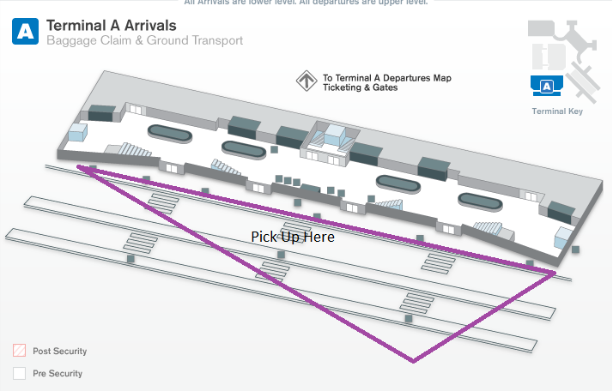

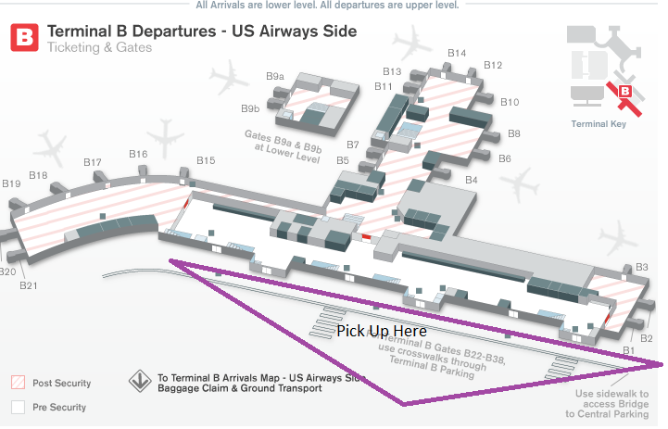

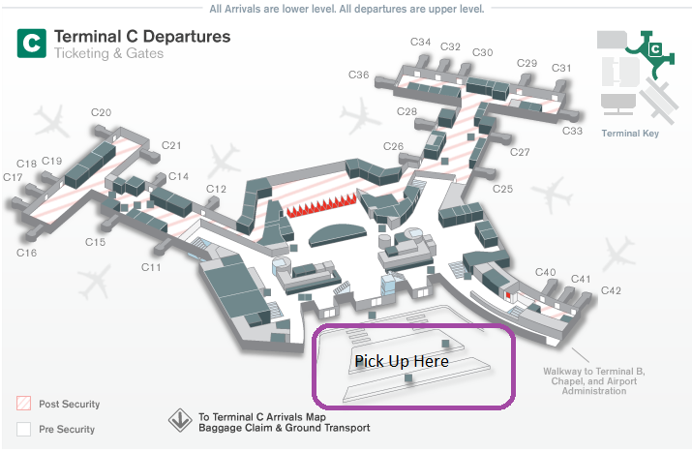

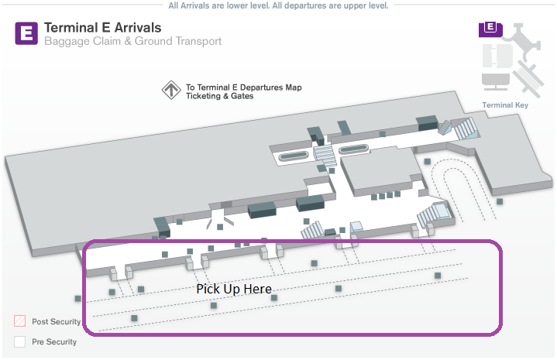

JFK International Airport-New York

Terminal 1: Aeroflot, Aero Mexico, Air China, Air France, Alitalia, Austrian Airlines, Brussels Airlines, Cayman Airways, China Eastern, EVA Airways, Fly Jamaica Airways, Interjet, Japan Airlines, Korean Air, LOT, Lufthansa, Meridiana Fly, Norwegian Air Shuttle, Royal Air Maroc, Saudi Arabian Airlines, Turkish,

Terminal 2: Delta (Domestic),

Terminal 4: Air Europa, Air India, Air Jamaica, Arik Air, Asiana, Avianca, Caribbean, China Airlines, Copa Airlines, Czech Airlines, Delta (International), Egyptair, EL AL, Emirates, Etihad, KLM Royal Dutch Airlines, Kuwait Airways, Lacsa, Miami Air, North American, Pakistan International Airlines, Singapore Airlines, South African Airways, Sun Country, SWISS, TACA International, Transaero Airlines, Uzbekistan, Virgin America, Virgin Atlantic, XL Airways

Terminal 5: Aer Linqus, Hawaiian Airlines, JetBlue,

Terminal 7: Air Canada, ANA, British Airways, Cathay Pacific, Iberia, Icelandair, Open Skies, Qantas, United Airlines, US Airways,

Terminal 8: Air Berlin, American, American Eagle, Finnair, Lan Chile, Lan Ecuador, Lan Peru, Qatar Airways, Royal Jordanian, TAM

JFK International Airport has eight terminals; however, only six are in use. As the airport is arrayed in a large oval, your vehicle will be parked outside your respective terminal. After you collect your luggage, feel free to call your driver if their number has been provided or requested. Your driver will be waiting for you outside the gate with a sign containing your last name. For International flights, your driver will be waiting outside of customs with a sign containing your last name. If your driver has been given your phone number, they will call you fifteen minutes after you land.

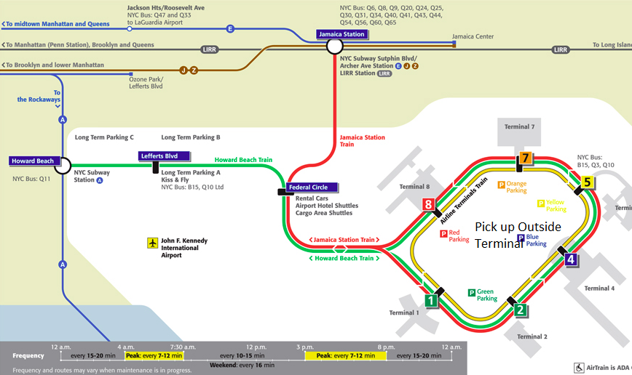

La Guardia-New York

Terminal A: Delta Shuttle

Terminal B: Air Canada, Air Tran Airways, American Airlines, American Eagle, Frontier Airlines, JetBlue Airways, Southwest Airlines, Spirit, United, United Express,

Terminal C: Delta, US Airways, US Airways Express, US Airways Shuttle, WestJet

Terminal D: Delta, Delta Connection

La Guardia, the smallest of the three main New York Airports, has very strict livery regulations. As such, your limo and driver will wait for you in lot 11. When your flight has landed, your driver will meet you outside of your terminal. After you collect your luggage, feel free to call your driver if their number has been provided or requested. If your driver has been given your phone number, they will call you fifteen minutes after you land.

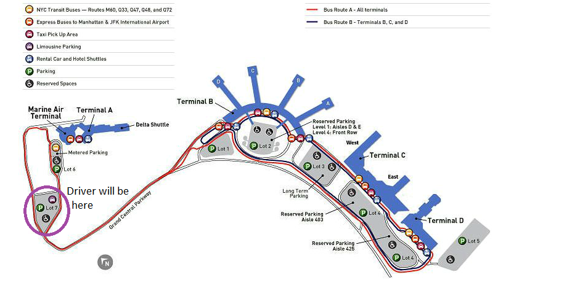

Newark Liberty International Airport

Terminal A: Air Canada, American, American Eagle, Jet Blue, Southwest, United Express, US Airways, US Airways Express, Virgin America, WestJet

Terminal B: Air India, Alaska Airlines, British Airways, Delta, EL AL, Jet Airways, Lufthansa, Open Skies, Porter Airlines, SAS, Singapore Airlines, Swiss, TAP Portugal, Virgin Atlantic,

Terminal C: United, United Express

